2. Python program to print the pattern

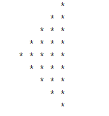

def pattern(n):

k = 2 * n - 2

for i in range(0, n-1):

for j in range(0, k):

print(end=" ")

k = k - 2

for j in range(0, i + 1):

print("* ", end="")

print("")

k = -1

for i in range(n-1,-1,-1):

for j in range(k,-1,-1):

print(end=" ")

k = k + 2

for j in range(0, i + 1):

print("* ", end="")

print("")

pattern(5)

**output:**

